


DEPI Final project :

Smart clinic management system

Submitted by:
- Anas Mohammed Elsayed
- Yousef Mohammed Ali
- Asmaa Ashraf Elsadik
- Ahmed Ehab
- Zyad Nabil

Academic Year 2025 – 2026

Table of Contents :

1. Project Idea

2. Problem Statement

3. Project Objectives

4. Project Scope

5. Gantt Chart

6. Project Risks

7. Mitigation Plan

8. Communication Plan

9. System Users

9.1 Administrator

9.2 Doctor

9.3 Receptionist

9.4 Patient

10. Activity Diagrams

10.1 Login Activity Diagram

10.2 Appointment Scheduling Activity Diagram

10.3 Billing Activity Diagram

10.4 Medical Record Activity Diagram

11. Class Diagram

11.1 Class Diagram

12. Create Actor List

13. Write User Stories

14. Define Use Cases

14.1 Use Case Diagram

14.2 DFD Level 0 (Context Diagram)

14.3 DFD Level 1

15. Functional Requirements

16. Non-Functional Requirements

17. Security Requirements

18. Performance Requirements

19. Use Case Description

20. System Architecture

20.1 System Architecture Overview

Figure 20.1 System Architecture Diagram

21. Technology Stack

21.1 Frontend Technologies
- React
- TypeScript
- Vite
- Tailwind CSS

21.2 Backend Technologies
- ASP.NET Core MVC

21.3 Database Technologies
- Firebase Firestore

21.4 Authentication Technologies
- Firebase Authentication

21.5 Deployment Technologies

22. Database Design

22.1 Initial SQL Server Design

22.2 Entity Relationship Diagram (ERD)

22.3 Migration from SQL Server to Firebase Firestore

23. Firestore Database Design

23.1 Firestore Collections

23.1.1 Users Collection

23.1.2 Admins Collection

23.1.3 Doctors Collection

23.1.4 Receptionists Collection

23.1.5 Patients Collection

23.1.6 Departments Collection

23.1.7 Appointments Collection

23.1.8 Medical Records Collection

23.1.9 Prescriptions Collection

23.1.10 Billing Collection

23.1.11 Notifications Collection

23.1.12 Audit Logs Collection

23.2 Collection Relationships

23.3 Sample Documents

24. Application Pages Description

24.1 Login Page

24.2 Dashboard

24.3 User Management

24.4 Patient Management

24.5 Doctor Management

24.6 Appointment Management

24.7 Medical Records

24.8 Prescriptions

24.9 Billing and Invoices

24.10 Reports and Analytics

24.11 Notifications

24.12 Audit Logs

25. Testing

25.1 Testing Strategy

25.2 Functional Testing

25.3 Integration Testing

25.4 User Acceptance Testing (UAT)

25.5 Test Cases

26. Challenges Faced

26.1 Migration from SQL Server to Firebase Firestore

26.2 Authentication and Authorization

26.3 Firestore Data Modeling

26.4 Role Management

26.5 Team Coordination and Development

27. Lessons Learned

27.1 NoSQL Database Design

27.2 Firebase Ecosystem Integration

27.3 Frontend Development Best Practices

27.4 Team Collaboration

27.5 Agile Development Practices

28. Future Work

28.1 Mobile Application

28.2 Online Payment Integration

28.3 SMS and Email Notifications

28.4 AI-Based Appointment Recommendations

28.5 Multi-Clinic Support

28.6 Advanced Analytics and Reporting

29. Conclusion

29.1 Project Summary

29.2 Achieved Objectives

29.3 Final Remarks

1. Project idea :
- The Smart Clinic Management System is a web-based application designed to help clinics manage their daily operations efficiently through a digital platform.

- Many clinics still rely on manual systems such as paper records or spreadsheets to manage patients, appointments, and billing. These traditional methods can lead to problems such as lost records, scheduling conflicts, difficulty accessing patient history, and inefficient administrative processes.

- The Smart Clinic Management System aims to solve these issues by providing an integrated platform where clinic staff can manage patient information, doctor schedules, appointments, medical records, prescriptions, billing, and reports in an organized and secure way.

- The system is developed using React, TypeScript, Vite, and Tailwind CSS for the frontend, ASP.NET Core MVC for backend services, Firebase Firestore as the cloud NoSQL database, and Firebase Authentication for secure user authentication and authorization. The application is deployed on Netlify.

- The system supports four user roles: Admin, Doctor, Receptionist, and Patient, allowing each user to access specific features based on their responsibilities.
2. Problem Statement :
Many clinics, especially small and medium-sized ones, still depend on manual record-keeping systems to manage patient information, appointments, and billing. This approach often leads to several problems including:
- Difficulty in managing and searching patient records
- Appointment scheduling conflicts
- Loss or damage of paper records
- Lack of centralized patient medical history
- Inefficient billing and payment tracking
- Limited access to reports and clinic statistics
These issues can reduce the overall efficiency of clinic operations and negatively impact patient care and service quality.
Therefore, there is a need for a digital clinic management system that can store, organize, and manage clinic data efficiently while improving workflow and reducing administrative errors, and supporting role-based access for different users.

3. Project Objectives :
The main objective of the Smart Clinic Management System is to develop a secure and efficient digital solution that helps clinics manage their daily operations.

Specific Objectives
- To implement secure user authentication using Firebase Authentication.
- To manage users and their roles within the system.
- To create a patient management module for storing and updating patient information.
- To implement an appointment scheduling system to organize patient visits.
- To allow doctors to create and manage medical records and prescriptions.
- To develop a billing system for invoices and payment tracking.
- To provide reports and statistics about patients, appointments, and revenue.
- To build a dashboard that displays important clinic data in a clear and organized way.
- To maintain audit logs that track user activities for security and monitoring
4. Project Scope :
The scope of the Smart Clinic Management System includes the development of a web application that manages core clinic operations.

The system will include the following modules:
- Authentication and Authorization
- User Management
- Roles and Permissions
- Patient Management
- Doctor Management
- Appointment Scheduling
- Medical Records Management
- Prescription Management
- Billing and Invoice Management
- Department Management
- Dashboard and Analytics
- Notifications
- Audit Logs

System Users

The system supports four user roles:
- Admin – manages users, roles, departments, reports, dashboards, and system settings.
- Doctor – manages appointments, medical records, prescriptions, and patient history.
- Receptionist – registers patients, schedules appointments, and manages billing.
- Patient – views appointments, prescriptions, and medical records.

Limitations
- The system is designed for a single clinic.
- It is accessed through a web browser.
- Internet connectivity is required to access Firebase services.
- The current version does not support multiple clinic branches.

5.Gantt chart :

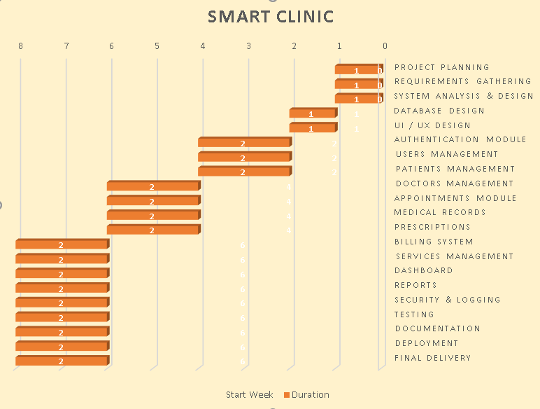

6. Project risks identification table :

Risk ID | Risk Description | Category | Possible Impact
R1 | Team member becomes unavailable during the project | Resource Risk | Delays in completing sprint tasks
R2 | Poor communication between team members | Management Risk | Misunderstandings and development errors
R3 | Incorrect database design or relationships | Technical Risk | Data inconsistency and system errors
R4 | Security vulnerabilities in authentication system | Security Risk | Unauthorized access to the system
R5 | Loss of database data due to system failure | Technical Risk | Loss of patient and appointment records
R6 | Integration issues between frontend and backend | Technical Risk | System features may not work correctly
R7 | Delay in completing sprint tasks | Schedule Risk | Project timeline delays
R8 | Bugs in appointment scheduling logic | Technical Risk | Appointment conflicts between patients
R9 | Unauthorized access to patient medical records | Security Risk | Violation of patient privacy
R10 | Incorrect billing or payment calculations | Technical Risk | Financial errors in the system
R11 | Performance issues when handling many records | Performance Risk | Slow system response
R12 | Lack of proper testing before deployment | Quality Risk | Undetected system bugs
R13 | Server or hosting issues during deployment | Infrastructure Risk | System becomes unavailable
R14 | Improper role and permission configuration | Security Risk | Users accessing restricted data
R15 | Loss of project files or code | Resource Risk | Need to redo development work

7. Mitigation plan table :

Risk ID | Risk Description | Mitigation Strategy
R1 | Team member becomes unavailable | Share project knowledge among team members and maintain documentation
R2 | Poor communication within the team | Hold weekly meetings and use task management tools
R3 | Incorrect database design | Review ER diagram before database implementation
R4 | Security vulnerabilities in authentication | Use secure authentication and password hashing
R5 | Data loss in the database | Perform regular database backups
R6 | Integration issues between frontend and backend | Conduct regular integration testing
R7 | Delay in completing sprint tasks | Monitor sprint progress and adjust task assignments
R8 | Bugs in appointment scheduling | Implement validation logic and perform testing
R9 | Unauthorized access to patient records | Apply role-based access control
R10 | Incorrect billing calculations | Test billing module with multiple scenarios
R11 | Performance issues | Optimize database queries and indexing
R12 | Lack of proper testing | Create test cases and perform system testing
R13 | Server or hosting issues | Prepare deployment environment and backups
R14 | Incorrect role permissions | Review role permissions before deployment
R15 | Loss of project files | Use version control and backup repositories

8.Communication plan :

A communication plan was established to ensure effective coordination between all members of the development team. Regular meetings and communication tools are used to share project updates, discuss technical issues, and monitor sprint progress. The project leader is responsible for coordinating communication and reporting progress to the project supervisor.

Communication plan table

Communication Type | Participants | Method | Frequency | Purpose
Project Planning Meeting | All team members | Meeting / Online call | At project start | Define project goals and tasks
Weekly Team Meeting | All team members | Online meeting | Weekly | Discuss progress and issues
Sprint Review Meeting | Team + Leader | Meeting | Every 2 weeks | Review sprint progress
Task Updates | Team members | Task management tool | Continuous | Update task status
Technical Discussion | Backend + Database + Frontend | Messaging / meeting | When needed | Solve technical problems
Progress Reporting | Leader → Supervisor | Email / report | Bi-weekly | Inform supervisor about project progress
Final Project Review | Team + Supervisor | Presentation | End of project | Demonstrate final system

9.System users :
The Smart Clinic Management System is designed to support different types of users with specific responsibilities. Each user role has different permissions and access levels within the system to ensure proper management of clinic operations.
The primary users of the system include the system administrator, doctors, and receptionists.
User Role | Description
Admin | Manages system configuration, users, roles, and reports
Doctor | Views patients, creates medical records, and issues prescriptions
Receptionist | Registers patients, schedules appointments, and manages billing

10.Activity diagrams :
  - Login
  - Appointment Scheduling
  - Billing process
  - Medical record creation
  - Patients registration

1-Login :
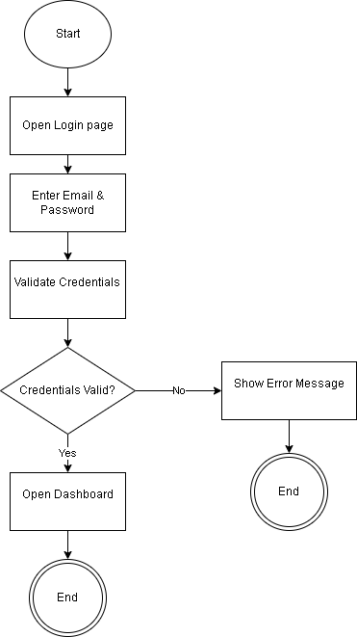

2-Appointment Scheduling :
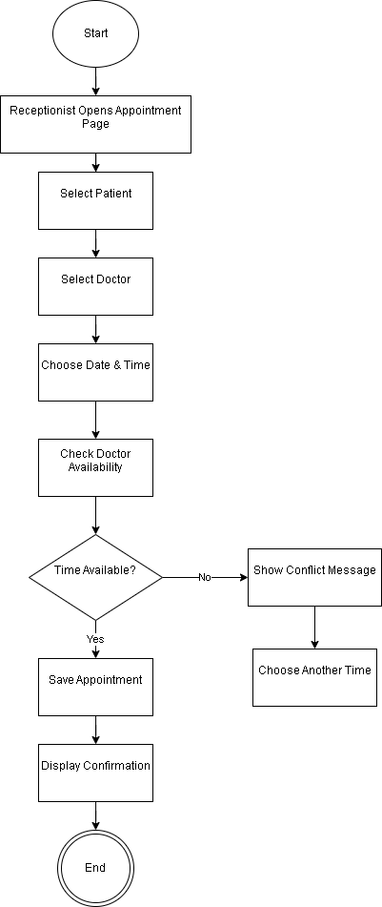

3-Billing process :
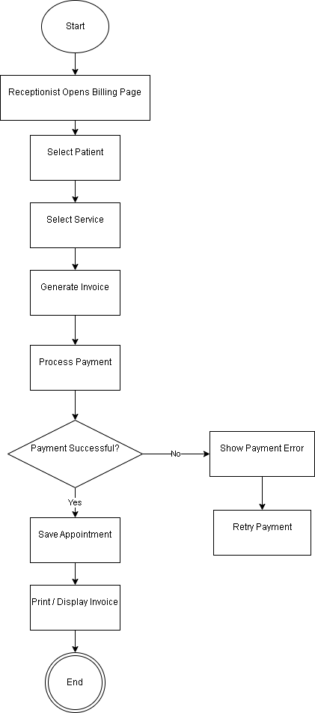

4- Medical record creation:
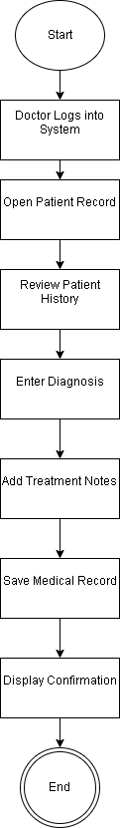

5-Patients registration:
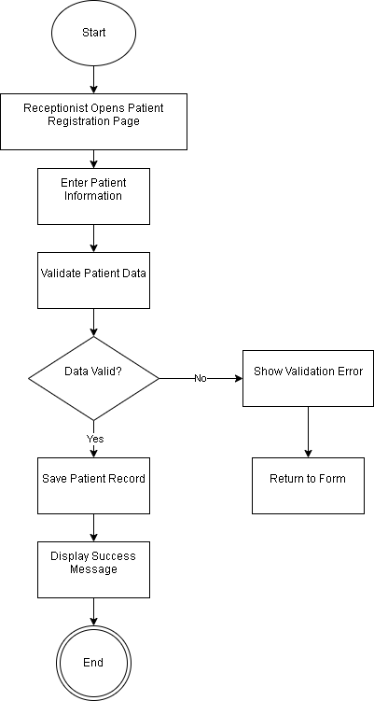

11-Class Diagram :
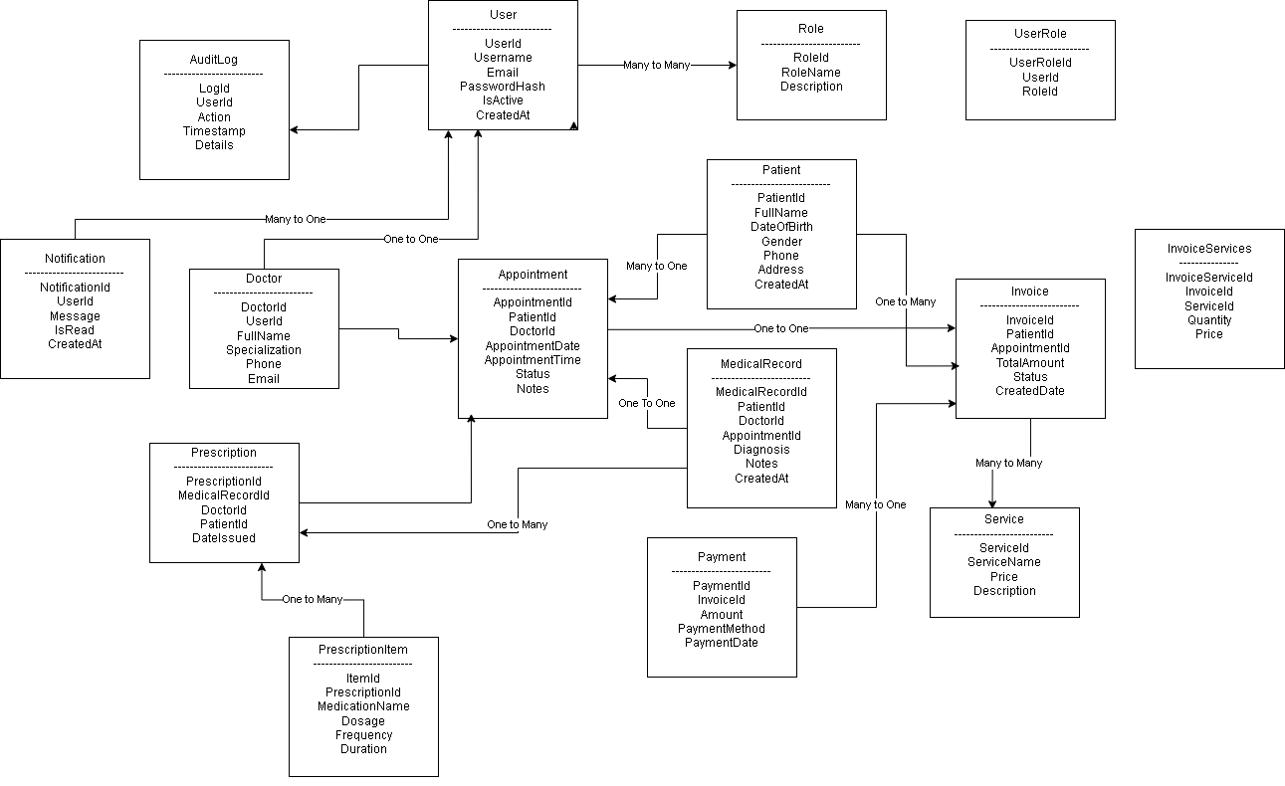

12. Actor List

The system interacts with three primary actors, each with specific access levels and responsibilities:
- Admin: Manages users, roles, departments, appointments, reports, dashboard, notifications, audit logs, and system settings.
- Doctor: Views patient information, manages appointments, creates and updates medical records, and issues medical prescriptions.
- Receptionist: Registers new patients, schedules and manages appointments, generates invoices, and manages billing.
- Patient: Views personal profile, appointments, medical records, and prescriptions.

13. User Stories

Admin
- As an Admin, I want to manage users, roles, and permissions so that only authorized users can access the system.
- As an Admin, I want to manage departments so that doctors are organized efficiently.
- As an Admin, I want to view reports and audit logs so that I can monitor clinic activities and ensure system security.

Doctor
- As a Doctor, I want to view a patient's medical history so that I can provide an accurate diagnosis.
- As a Doctor, I want to create and update medical records and prescriptions so that the patient's treatment plan is properly documented.
- As a Doctor, I want to view my appointments so that I can manage my daily schedule.

Receptionist
- As a Receptionist, I want to register new patients so that their information is stored in the system.
- As a Receptionist, I want to schedule, update, or cancel appointments so that doctors' schedules remain organized.
- As a Receptionist, I want to generate invoices and manage billing so that clinic payments are accurately recorded.

Patient

- As a Patient, I want to view my appointments so that I know my upcoming visits.
- As a Patient, I want to view my medical records and prescriptions so that I can follow my treatment plan.

14. Use Cases

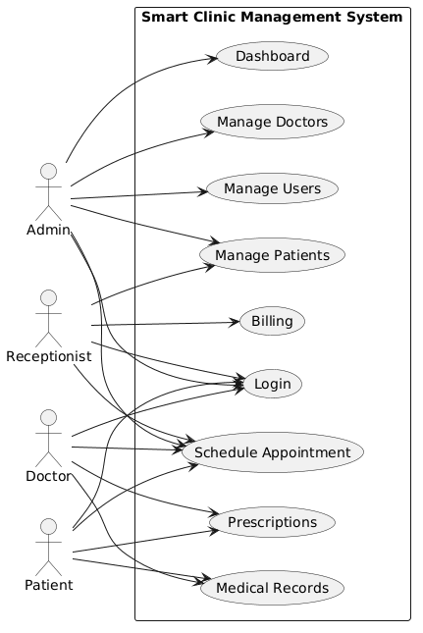
Figure 14.1 : Use case diagram

- UC-01: User Authentication – Secure login and logout using Firebase Authentication.
- UC-02: Manage Users & Roles – Admin creates, updates, deletes users, and assigns roles.
- UC-03: Manage Departments – Admin manages clinic departments.
- UC-04: Manage Patients – Receptionist registers, updates, and manages patient profiles.
- UC-05: Schedule Appointments – Receptionist schedules, updates, and cancels appointments while checking doctor availability.
- UC-06: Manage Medical Records & Prescriptions – Doctor creates and updates medical records and prescriptions.
- UC-07: Manage Billing & Invoices – Receptionist generates invoices and manages billing information.
- UC-08: View Dashboard & Reports – Admin views dashboards, reports, and analytics.
- UC-09: Manage Notifications – System sends notifications related to appointments and important events.
- UC-10: View Patient Information – Patient views appointments, medical records, and prescriptions.

14.2 DFD Level 0 (Context Diagram)

Overview
The Context Diagram represents the Smart Clinic Management System at the highest level of abstraction. It illustrates the system as a single process and shows how external entities interact with it through data flows.
The main external entities interacting with the system are the Administrator, Doctor, Receptionist, and Patient. These users exchange information with the system to perform various healthcare and administrative operations.

Description
The Administrator interacts with the system to manage users, departments, appointments, reports, and system settings. The system provides administrative reports, user information, and operational statistics in response to administrative requests.
The Doctor accesses patient information, medical records, prescriptions, and appointment schedules. The system stores and retrieves medical data to support patient diagnosis and treatment.
The Receptionist is responsible for patient registration, appointment scheduling, billing management, and notification handling. The system processes these requests and updates the corresponding records.
The Patient interacts with the system to view appointments, prescriptions, medical records, and notifications. The system provides secure access to the patient's personal healthcare information.
The Context Diagram demonstrates how all users communicate with a single integrated healthcare management platform while maintaining centralized control over clinic operations.
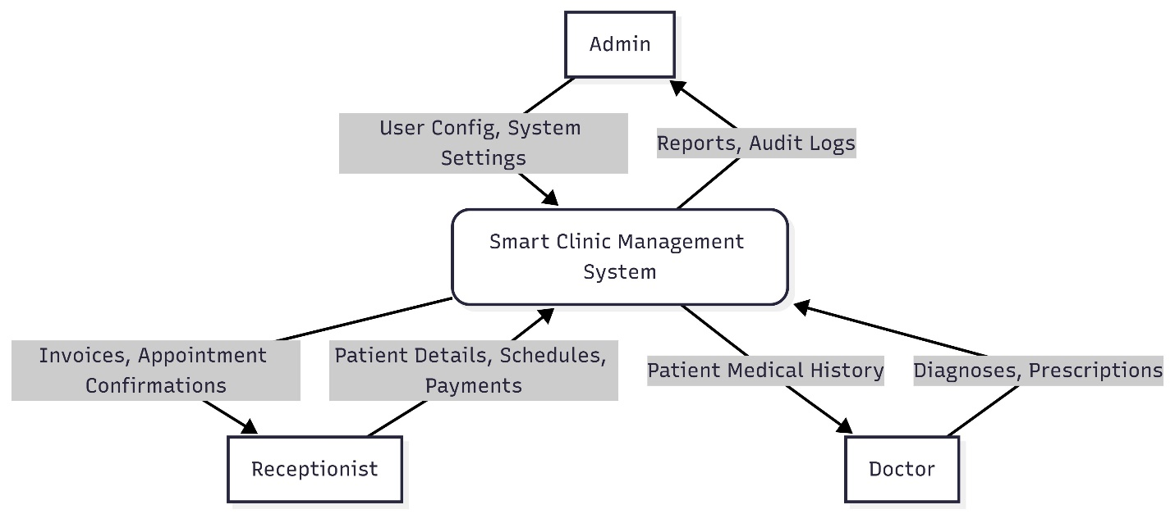
Figure 14.2: DFD Level 0 (Context Diagram)

14.3 DFD Level 1

Overview
The Level 1 Data Flow Diagram (DFD) expands the Context Diagram by decomposing the Smart Clinic Management System into its major functional processes. It illustrates how data flows between users, system processes, and data stores.

Description
The system is divided into several core processes:

1. Authentication and User Management
This process handles user registration, login, role verification, and account management. User information is stored in the Users data store and validated through Firebase Authentication.

2. Patient Management
This process manages patient information, including registration, profile updates, and retrieval of medical history. Patient records are stored in the Patients data store.

3. Appointment Management
This process allows receptionists and patients to schedule appointments while enabling doctors to view their schedules. Appointment information is maintained in the Appointments data store.

4. Medical Records Management
Doctors create and update medical records during patient consultations. The system stores diagnoses, treatments, and clinical notes in the Medical Records data store.

5. Prescription Management
Doctors generate prescriptions that are linked to patient medical records. Prescription information is stored in the Prescriptions data store and can be accessed by authorized users.

6. Billing and Invoice Management
The system generates invoices and tracks payment information for clinic services. Billing records are maintained in the Billing and Invoices data store.

7. Notification Management
Notifications are generated to inform users about appointments, prescriptions, billing updates, and other important events. These notifications are stored in the Notifications data store.

8. Audit Logging
The Audit Logs process records important user actions and system activities for security monitoring and accountability purposes. These records are maintained in the Audit Logs data store.

Summary
The Level 1 DFD illustrates the internal structure of the Smart Clinic Management System and demonstrates how data moves between users, system processes, and database collections. It provides a detailed view of the system's functionality and supports understanding of the overall system design.
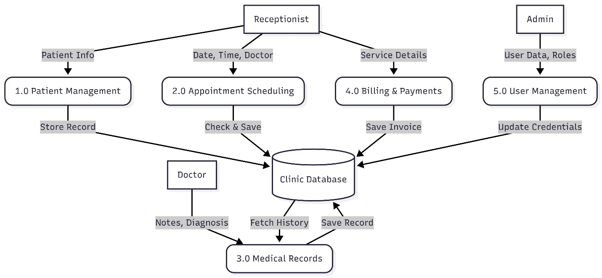
Figure 14.3: DFD Level 1

15. Functional Requirements

The Smart Clinic Management System shall provide the following functional requirements:
- The system shall provide secure authentication for Admins, Doctors, Receptionists, and Patients using Firebase Authentication.
- The system shall allow the Admin to create, update, delete, and manage users, roles, departments, and system settings.
- The system shall allow the Receptionist to create, read, update, and delete (CRUD) patient records.
- The system shall allow the Receptionist to schedule, update, and cancel appointments while validating doctor availability to prevent scheduling conflicts.
- The system shall allow Doctors to create, update, and manage patients' medical records.
- The system shall allow Doctors to create and manage prescriptions for patients.
- The system shall generate invoices and manage billing information.
- The system shall provide dashboards, reports, and analytics for clinic activities.
- The system shall send notifications for important events such as appointment updates.
- The system shall maintain audit logs to record user activities for security and monitoring purposes.
- The system shall allow Patients to view their appointments, medical records, and prescriptions.

16. Non-Functional Requirements
- The system shall provide a secure login mechanism for Admins, Doctors, ,Receptionists and Patient.
- The system shall allow the Receptionist to create, read, update, and delete (CRUD) patient records.

- The system shall allow the Receptionist to schedule appointments and validate doctor availability to prevent scheduling conflicts.

- The Platform: The system must be a web-based application accessible via standard web browsers.

- Technology Stack: The application is developed using a modern web technology stack. The frontend is built with React, TypeScript, Vite, and Tailwind CSS to provide a responsive and interactive user interface. The backend is implemented using ASP.NET Core MVC, following a layered architecture with Controllers, Models, and Services. For data storage and user authentication, the system uses Firebase Firestore as the cloud NoSQL database and Firebase Authentication to provide secure authentication and role-based access control. The application is deployed on Netlify.

- Scalability: The system is designed for single-clinic usage while allowing future expansion and handling increasing amounts of data.

- Availability: The system should be available at all times except during scheduled maintenance.

- Usability: The user interface should be responsive, intuitive, and easy to use across different devices and screen sizes.

17. Security Requirements
- Access Control: The system must implement Role-Based Access Control (RBAC) to ensure users only access features permitted by their specific roles (Admin, Doctor, Receptionist, and Patient).

- Authentication: User credentials must be securely authenticated using Firebase Authentication before granting access to the system.

- Data Privacy: Patient medical records must be restricted strictly to authorized users to prevent unauthorized access.

18. Performance Requirements
- Response Time: The system shall respond to normal user requests within 2–3 seconds under regular operating conditions.

- Data Integrity: Firebase Firestore shall ensure accurate storage and retrieval of clinic data while preventing data inconsistency.

- Scalability: The system shall support an increasing number of patients, appointments, and medical records without significant performance degradation.

- Availability: The system shall provide reliable access to users through cloud-hosted services.

19. Use Case Description

Use Case: Schedule Appointment
- Actor: Receptionist
- Goal: Successfully book an appointment for a patient with a specific doctor.
- Pre-conditions: The Receptionist is logged in, and the patient is registered in the system.
- Main Success Scenario:
  - Receptionist opens the Appointment Page.
  - Receptionist selects the Patient and the Doctor.
  - Receptionist chooses the Date & Time.
  - The system checks the doctor's availability.
  - The system confirms the time is available.
  - The system saves the appointment.
  - The system displays a confirmation message.
- Alternative Flow (Conflict):
  - In step 5, if the time is not available, the system shows a "Conflict Message".
  - The Receptionist must choose another time.

20. System Architecture

20.1 System Architecture Overview
The Smart Clinic Management System follows a multi-layer architecture that separates the presentation layer, authentication layer, data layer, and backend services. This architecture improves scalability, maintainability, security, and performance by assigning specific responsibilities to each layer.
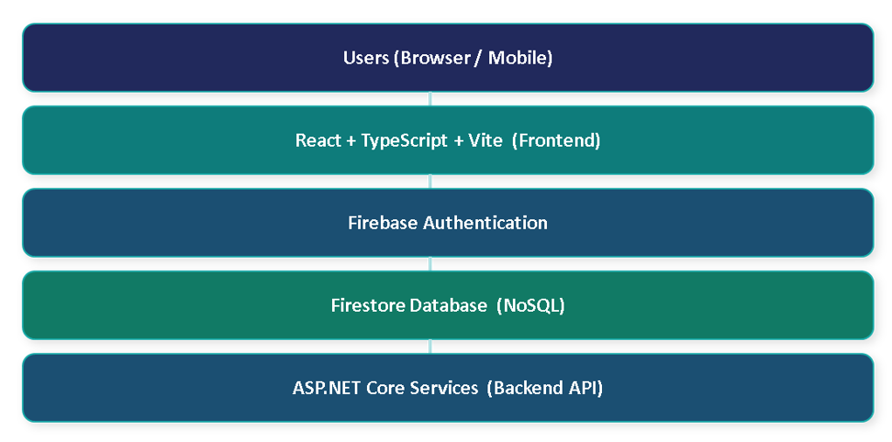
Figure 20.1: High-Level Architecture of the Smart Clinic Management System

The architecture consists of five main layers:

1. Users Layer
The system is accessed by different user roles through web browsers or mobile devices. The supported users are:
- Admin
- Doctor
- Receptionist
- Patient
Users interact with the system through a responsive web interface that allows them to perform their authorized tasks according to their assigned roles.

2. Frontend Layer (React + TypeScript + Vite)
The frontend is developed using React, TypeScript, and Vite.
Responsibilities of this layer include:
- Displaying the user interface.
- Handling user interactions.
- Form validation.
- Navigation between pages.
- Communicating with Firebase services and backend APIs.
- Managing application state.
The use of React provides a component-based architecture that improves code reusability and maintainability, while TypeScript enhances code quality through static type checking.

3. Authentication Layer (Firebase Authentication)
Firebase Authentication is responsible for managing user authentication and identity verification.
Main functions include:
- User login and logout.
- Secure credential validation.
- Session management.
- User identity verification.
- Integration with role-based access control.
When a user logs into the system, Firebase Authentication validates the credentials and generates an authentication token that is used to access protected resources.

4. Database Layer (Firestore Database)
The system uses Firebase Firestore as a cloud-based NoSQL database.
Firestore stores all system data, including:
- Users
- Patients
- Doctors
- Appointments
- Medical Records
- Prescriptions
- Billing Information
- Notifications
- Audit Logs
Firestore provides:
- Real-time synchronization.
- High availability.
- Automatic scaling.
- Flexible document-based data modeling.
The database is organized using collections and documents rather than traditional relational tables.

5. Backend Services Layer (ASP.NET Core API)
ASP.NET Core services are used to implement business logic and backend operations that require additional processing.
Responsibilities include:
- Processing complex business rules.
- Data validation.
- Report generation.
- Integration with external services.
- Supporting future system expansion.
The backend layer communicates with Firestore and serves as an additional service layer between the frontend and the database when needed.

System Workflow
The overall workflow of the system is as follows:
- A user accesses the application through a browser or mobile device.
- The React frontend displays the required pages and collects user input.
- User credentials are verified using Firebase Authentication.
- After successful authentication, the system determines the user's role and permissions.
- The frontend retrieves or updates data stored in Firestore.
- For advanced operations, requests may be processed through ASP.NET Core backend services.
- The results are returned and displayed to the user through the frontend interface.

21. Technology Stack
The Smart Clinic Management System was developed using modern web technologies to ensure high performance, scalability, maintainability, and security. The selected technology stack supports rapid development, cloud-based data management, secure authentication, and efficient deployment.

21.1 Frontend Technologies
The frontend of the system is responsible for providing an interactive and responsive user interface for all system users, including administrators, doctors, receptionists, and patients.

React
React is a JavaScript library used for building dynamic user interfaces through reusable components. It enables efficient rendering and state management, making the application more responsive and maintainable. React was chosen because of its component-based architecture, large ecosystem, and strong community support.

TypeScript
TypeScript is a statically typed superset of JavaScript that enhances code quality and reliability. It provides type checking during development, helping developers detect errors early and improve code maintainability. TypeScript was used throughout the project to improve scalability and reduce runtime errors.

Vite
Vite is a modern frontend build tool used to improve development speed and application performance. It provides fast startup times, efficient hot module replacement (HMR), and optimized production builds. Vite was selected to streamline the development process and improve developer productivity.

Tailwind CSS
Tailwind CSS is a utility-first CSS framework used to design responsive and modern user interfaces. It enables rapid UI development through reusable utility classes and reduces the need for custom CSS files. Tailwind CSS was used to create a consistent and responsive design across all application pages.

21.2 Backend Technologies

ASP.NET Core MVC
ASP.NET Core MVC was used as the backend service layer to support business logic, data processing, and future system integration requirements. The framework provides high performance, security, and flexibility for developing enterprise-level applications.
The backend services are responsible for:
- Processing business rules.
- Performing server-side validation.
- Handling complex operations.
- Supporting future integrations and extensions.
- Providing additional API services when required.
ASP.NET Core was selected due to its scalability, reliability, and strong support for modern web application development.

21.3 Database Technologies

Firebase Firestore
Firebase Firestore is a cloud-based NoSQL database used to store and manage the application's data. Unlike traditional relational databases, Firestore stores information in collections and documents, providing greater flexibility for modern web applications.
Firestore is used to store:
- User accounts.
- Patient records.
- Doctor information.
- Appointments.
- Medical records.
- Prescriptions.
- Billing information.
- Notifications.
- Audit logs.
The main advantages of Firestore include:
- Real-time data synchronization.
- Automatic scalability.
- High availability.
- Flexible document-based structure.
- Reduced database administration requirements.
Firestore was selected after migrating from the initial SQL Server design to achieve faster development and simplified cloud integration.

21.4 Authentication Technologies

Firebase Authentication
Firebase Authentication is used to provide secure user authentication and identity management within the system. It supports secure login, session management, and user verification.
The authentication module is responsible for:
- User login and logout.
- Credential validation.
- Session management.
- User identity verification.
- Role-based access control integration.
Firebase Authentication was chosen because it offers built-in security features, seamless integration with Firestore, and reduces the complexity of managing authentication infrastructure.

21.5 Deployment Technologies

Netlify
Netlify is the cloud hosting platform used to deploy and host the Smart Clinic Management System. It provides a reliable and scalable environment for serving the frontend application.
Netlify offers several benefits, including:
- Continuous deployment from source code repositories.
- Fast global content delivery through CDN services.
- Automatic build and deployment processes.
- SSL certificate management.
- Simplified production hosting.
The deployment process allows updates to be automatically published whenever changes are pushed to the project repository, ensuring efficient release management and system availability.

Summary
The combination of React, TypeScript, Vite, Tailwind CSS, ASP.NET Core MVC, Firebase Firestore, Firebase Authentication, and Netlify provides a modern, secure, scalable, and high-performance technology stack suitable for healthcare management systems. This architecture enables efficient development, secure data management, and reliable deployment while supporting future system enhancements.

22. Database Design
The database design phase was one of the most important stages in the development of the Smart Clinic Management System. During the initial planning phase, the system was designed using a traditional relational database model based on Microsoft SQL Server. However, during implementation, the project migrated to Firebase Firestore to better support cloud-based development, scalability, and real-time data management.
This chapter presents both the original relational database design and the migration process that led to the final Firestore implementation.

22.1 Initial ERD Design
At the beginning of the project, the Smart Clinic Management System was planned as a traditional web application using Microsoft SQL Server as the primary database management system.
The relational database design was created to store and manage healthcare-related data while maintaining data integrity and relationships between entities.
The initial design included several core tables:
- Users
- Patients
- Doctors
- Departments
- Appointments
- Medical Records
- Prescriptions
- Billing and Invoices
- Notifications
- Audit Logs
Relationships between these entities were established using primary keys and foreign keys to ensure consistency and support complex queries.
The relational model was selected because it provides:
- Structured data organization.
- Strong consistency.
- Referential integrity.
- Support for complex relationships.
- Efficient transactional processing.
During this phase, an Entity Relationship Diagram (ERD) was developed to model the database structure and define the relationships among system entities.
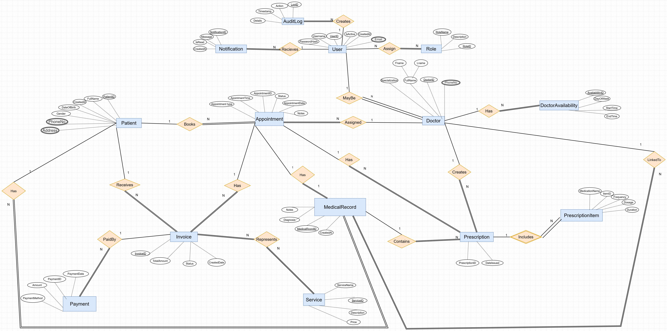
Figure 22.1 : Entity relational diagram

22.2 Migration from SQL Server to Firebase Firestore
Although the project was initially designed using Microsoft SQL Server, the implementation phase introduced new requirements related to cloud deployment, scalability, development speed, and real-time data access.
As a result, the development team decided to migrate from the traditional relational database approach to Firebase Firestore.

Reasons for Migration
Several factors influenced the decision to migrate to Firebase Firestore:

Cloud-Based Infrastructure
Firestore provides a fully managed cloud database service that eliminates the need for server administration and database maintenance.

Faster Development
The integration between Firebase services and the React frontend accelerated the development process and reduced backend complexity.

Real-Time Data Synchronization
Firestore supports real-time updates, allowing data changes to be reflected immediately across connected users and devices.

Scalability
Firestore automatically scales according to application usage without requiring manual configuration.

Firebase Ecosystem Integration
Firestore integrates seamlessly with Firebase Authentication, enabling secure user management and simplified access control.

Benefits of Firebase Firestore
After migration, the system gained several advantages:
- Simplified cloud deployment.
- Reduced infrastructure management.
- Improved development speed.
- Real-time database capabilities.
- Flexible NoSQL document structure.
- Seamless integration with Firebase Authentication.
- Automatic scaling and high availability.
These benefits made Firestore more suitable for the project's requirements and deployment environment.

23. Firestore Database Design
The final implementation of the Smart Clinic Management System uses Firebase Firestore as its primary database management system. Firestore is a cloud-based NoSQL database that stores data in collections and documents rather than traditional relational tables.
The Firestore database was designed to support the core functionalities of the system, including user management, patient records, appointment scheduling, medical records, prescriptions, billing, notifications, and audit logging.
The database structure was optimized to provide scalability, flexibility, and seamless integration with Firebase Authentication.

23.1 Firestore Collections
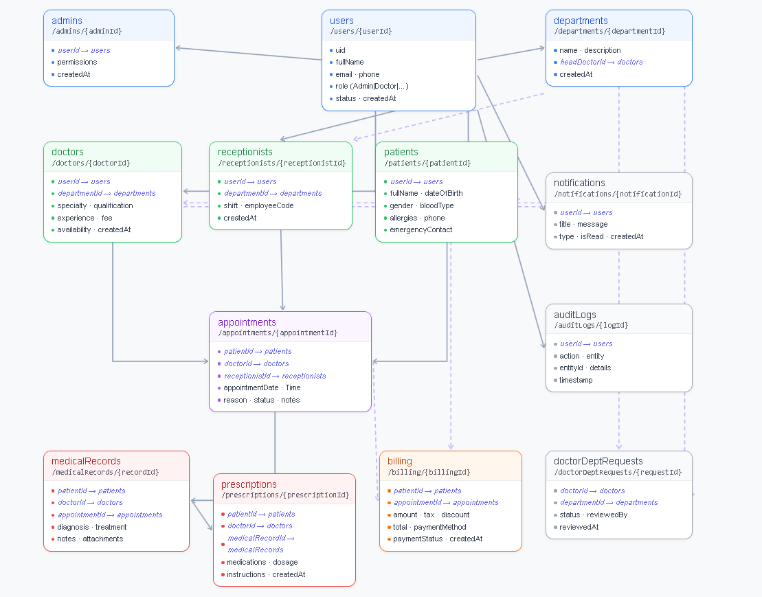

Figure 23.1: Firestore Collections Structure of the Smart Clinic Management System
The Firestore database consists of the following main collections:

Users Collection
Collection Path:
/users/{userId}
The Users collection stores general information for all system users regardless of their role.

Fields
Field | Description
uid | Unique user identifier
fullName | User full name
email | User email address
phone | User phone number
role | User role (Admin, Doctor, Receptionist, Patient)
status | Account status
createdAt | Creation date
This collection serves as the central user repository and integrates directly with Firebase Authentication.

Admins Collection
Collection Path:
/admins/{adminId}
Stores administrator-specific information.

Fields
Field | Description
userId | Reference to Users collection
permissions | Administrative permissions
createdAt | Creation date

Doctors Collection
Collection Path:
/doctors/{doctorId}
Stores doctor profiles and professional information.

Fields
Field | Description
userId | Reference to Users
departmentId | Assigned department
specialty | Medical specialty
qualification | Academic qualifications
experience | Years of experience
availability | Availability schedule
createdAt | Creation date

Receptionists Collection
Collection Path:
/receptionists/{receptionistId}
Stores receptionist information.

Fields
Field | Description
userId | Reference to Users
departmentId | Assigned department
shift | Work shift
employeeCode | Employee code
createdAt | Creation date

Patients Collection
Collection Path:
/patients/{patientId}
Stores patient personal and medical information.

Fields
Field | Description
userId | Reference to Users
fullName | Patient name
dateOfBirth | Date of birth
gender | Gender
bloodType | Blood type
allergies | Known allergies
phone | Contact number
emergencyContact | Emergency contact

Departments Collection
Collection Path:
/departments/{departmentId}
Stores clinic department information.

Fields
Field | Description
name | Department name
description | Department description
headDoctorId | Department manager
createdAt | Creation date

Appointments Collection
Collection Path:
/appointments/{appointmentId}
Stores appointment scheduling information.

Fields
Field | Description
patientId | Reference to Patient
doctorId | Reference to Doctor
receptionistId | Reference to Receptionist
appointmentDate | Appointment date
time | Appointment time
reason | Visit reason
status | Appointment status
notes | Additional notes

Medical Records Collection
Collection Path:
/medicalRecords/{recordId}
Stores patient medical history and diagnoses.

Fields
Field | Description
patientId | Reference to Patient
doctorId | Reference to Doctor
appointmentId | Reference to Appointment
diagnosis | Diagnosis details
treatment | Treatment plan
notes | Clinical notes
attachments | Supporting files

Prescriptions Collection
Collection Path:
/prescriptions/{prescriptionId}
Stores medication prescriptions issued by doctors.

Fields
Field | Description
patientId | Reference to Patient
doctorId | Reference to Doctor
medicalRecordId | Related medical record
medications | Prescribed medications
dosage | Medication dosage
instructions | Usage instructions
createdAt | Creation date

Billing Collection
Collection Path:
/billing/{billingId}
Stores billing and invoice information.

Fields
Field | Description
patientId | Reference to Patient
appointmentId | Reference to Appointment
amount | Invoice amount
tax | Applied tax
discount | Discount amount
total | Final total
paymentMethod | Payment method
paymentStatus | Payment status
createdAt | Creation date

Notifications Collection
Collection Path:
/notifications/{notificationId}
Stores system notifications.

Fields
Field | Description
userId | Reference to User
title | Notification title
message | Notification content
type | Notification type
isRead | Read status
createdAt | Creation date

Audit Logs Collection
Collection Path:
/auditLogs/{logId}
Stores user activity and system event logs.

Fields
Field | Description
userId | User performing action
action | Action performed
entity | Affected entity
entityId | Entity identifier
details | Action details
timestamp | Log timestamp

23.2 Collection Relationships
Although Firestore is a NoSQL database and does not support traditional foreign keys, relationships between collections are maintained using document references and unique identifiers.
The main relationships are:

User Relationships
- One User may be an Admin.
- One User may be a Doctor.
- One User may be a Receptionist.
- One User may be a Patient.

Department Relationships
- One Department can contain multiple Doctors.
- One Department can contain multiple Receptionists.
- One Doctor may act as the Head Doctor of a Department.

Appointment Relationships
- One Patient can have multiple Appointments.
- One Doctor can have multiple Appointments.
- One Receptionist can create multiple Appointments.

Medical Record Relationships
- One Appointment may generate one Medical Record.
- One Patient can have multiple Medical Records.
- One Doctor can create multiple Medical Records.

Prescription Relationships
- One Medical Record can contain multiple Prescriptions.
- One Doctor can issue multiple Prescriptions.
- One Patient can receive multiple Prescriptions.

Billing Relationships
- One Appointment generates one Billing record.
- One Patient can have multiple Billing records.

Notification Relationships
- One User can receive multiple Notifications.

Audit Log Relationships
- One User can generate multiple Audit Log entries.

24. Authentication and Security
Security is a critical requirement in healthcare management systems due to the sensitive nature of patient and medical information. The Smart Clinic Management System implements multiple security mechanisms to ensure confidentiality, integrity, and controlled access to system resources.
The system utilizes Firebase Authentication for user verification, Role-Based Access Control (RBAC) for authorization, Firestore Security Rules for database protection, and Audit Logs for activity monitoring and accountability.

24.1 Firebase Authentication
Firebase Authentication is used to manage user identity and provide secure access to the system. It offers a reliable authentication mechanism that integrates seamlessly with Firebase services and reduces the complexity of implementing custom authentication solutions.
The authentication process consists of the following steps:
- The user enters their login credentials.
- Firebase Authentication validates the credentials.
- Upon successful authentication, Firebase generates a secure authentication token.
- The system retrieves the user's profile and role information.
- Access is granted according to the assigned permissions.

Authentication Features
- Secure login and logout functionality.
- User identity verification.
- Session management.
- Authentication token generation.
- Password protection and encryption.
- Integration with Firestore Security Rules.
- Role-based authorization support.

Authentication Workflow
- User submits login credentials.
- Firebase Authentication validates the credentials.
- Authentication token is generated.
- User role is retrieved from Firestore.
- Appropriate dashboard and system features are loaded.

24.2 Role-Based Access Control (RBAC)
Role-Based Access Control (RBAC) is implemented to restrict access to system features based on user responsibilities. Each authenticated user is assigned a specific role that determines the actions they are authorized to perform.
The system supports four primary roles:

Administrator
The administrator has full access to the system and is responsible for managing users, departments, permissions, and system configurations.
Permissions include:
- User management.
- Department management.
- Audit log access.
- Dashboard analytics.
- System monitoring.

Doctor
Doctors are responsible for managing patient healthcare information.
Permissions include:
- Viewing assigned appointments.
- Creating medical records.
- Managing prescriptions.
- Accessing patient history.
- Updating treatment information.

Receptionist
Receptionists manage clinic operations and appointment scheduling.
Permissions include:
- Patient registration.
- Appointment scheduling.
- Appointment updates.
- Billing management.
- Notification handling.

Patient
Patients can access their own healthcare information.
Permissions include:
- Viewing appointments.
- Viewing prescriptions.
- Viewing medical records.
- Receiving notifications.
- Updating personal profile information.

Role Permission Matrix
System Feature | Admin | Doctor | Receptionist | Patient
Manage Users | ✓ | ✗ | ✗ | ✗
Manage Departments | ✓ | ✗ | ✗ | ✗
View Patients | ✓ | ✓ | ✓ | Own Data Only
Manage Appointments | ✓ | View | ✓ | View
Medical Records | ✓ | ✓ | View | View Own
Prescriptions | ✓ | ✓ | View | View Own
Billing | ✓ | View | ✓ | View Own
Audit Logs | ✓ | ✗ | ✗ | ✗
RBAC ensures that users can only access information and operations relevant to their responsibilities.

24.3 Firestore Security Rules
Firestore Security Rules are used to protect database resources and enforce authorization policies at the database level.
These rules ensure that:
- Only authenticated users can access protected data.
- Users can only access data permitted by their roles.
- Unauthorized read and write operations are prevented.
- Sensitive healthcare information remains protected.

Security Objectives
The implemented security rules help achieve:
- Data confidentiality.
- Data integrity.
- Controlled access.
- User accountability.
- Protection against unauthorized access.

Example Security Rule
The following example illustrates the general concept of Firestore security validation:
rules_version = '2';

service cloud.firestore {
match /databases/{database}/documents {

match /users/{userId} {
allow read, write: if request.auth != null;
}
}
}
In the actual implementation, additional rules are applied to restrict access according to user roles and permissions.

Security Measures Implemented
- Authentication verification before database access.
- Role validation for protected operations.
- Access restrictions based on ownership and permissions.
- Audit logging of critical actions.
- Secure communication between client and Firebase services.

24.4 Audit Logs
The Audit Logs module records important system activities to support security monitoring, accountability, and system maintenance.
Every significant action performed within the system is tracked and stored in the AuditLogs collection.

Logged Information
The audit log records include:
- User identifier.
- Performed action.
- Affected entity.
- Entity identifier.
- Action details.
- Timestamp.

Examples of Logged Actions
- User login and logout.
- Patient registration.
- Appointment creation.
- Appointment modification.
- Medical record updates.
- Prescription generation.
- Billing transactions.
- Department modifications.
- User management operations.

Benefits of Audit Logging
Audit logging provides several advantages:
- Improved system transparency.
- User activity tracking.
- Security incident investigation.
- Compliance support.
- Administrative monitoring.
- Detection of unauthorized activities.

Audit Log Storage Structure
{
"userId": "USR001",
"action": "Create Appointment",
"entity": "Appointment",
"entityId": "APP001",
"details": "Appointment created successfully",
"timestamp": "2025-08-15T10:30:00Z"
}
The Audit Logs collection serves as an important security mechanism by maintaining a historical record of user actions and system events, helping administrators monitor and manage the clinic environment effectively.

Summary
The Smart Clinic Management System combines Firebase Authentication, Role-Based Access Control, Firestore Security Rules, and Audit Logging to establish a secure environment for managing healthcare data. These mechanisms ensure that only authorized users can access system resources while maintaining the confidentiality, integrity, and availability of sensitive medical information.

25. Application Pages Description
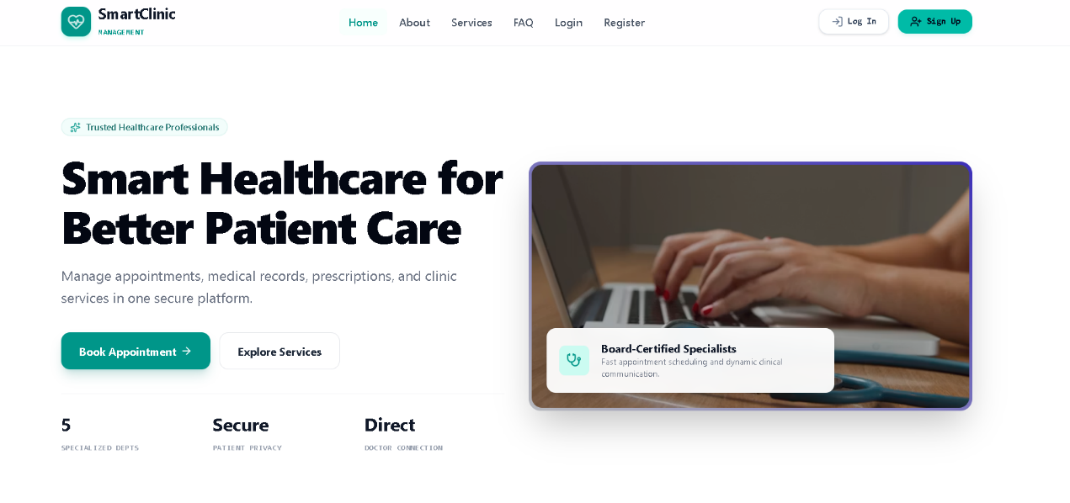

Home Page (Landing Page)
Purpose:
The main page of the Smart Clinic system that introduces the platform and its healthcare services.
Main Features:
- Displays clinic information and services.
- Allows users to navigate to Login or Register pages.
- Provides a quick Book Appointment button.
- Highlights key advantages:
  - 5 Specialized Departments
  - Secure Patient Privacy
  - Direct Doctor Communication
Database Interaction:
- May load departments and doctors dynamically from Firebase.
User Role:
- Public page (accessible to all visitors before login).

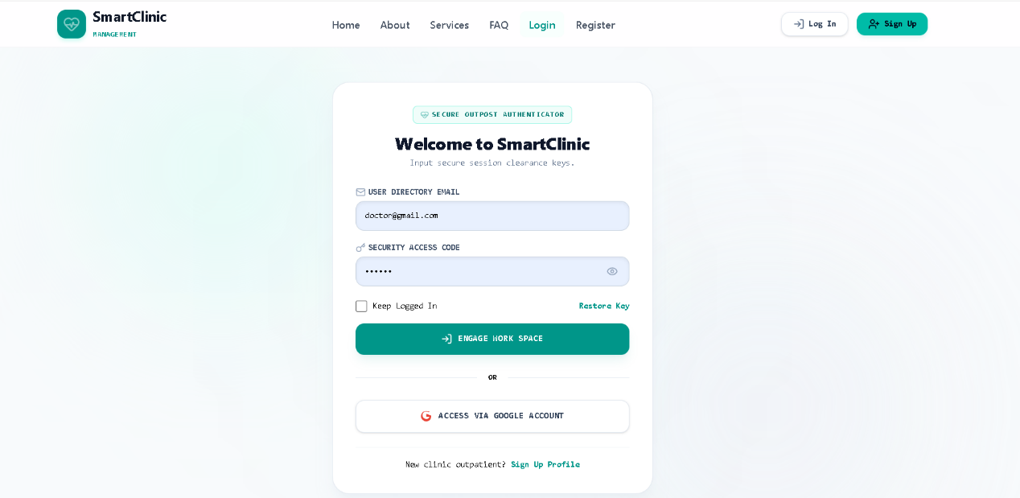

Login Page
Purpose:
Allows users to securely access the Smart Clinic system.
Main Features:
- Login using Email and Password.
- "Keep Logged In" option.
- Password recovery (Restore Key).
- Login with Google Account.
- Link to Registration Page.
Database Interaction:
- Verifies user credentials using Firebase Authentication.
- Retrieves user role (Admin, Doctor, Receptionist, Patient).
User Role:
- All system users.
After Login:
- Redirects users to their corresponding dashboard based on their role.

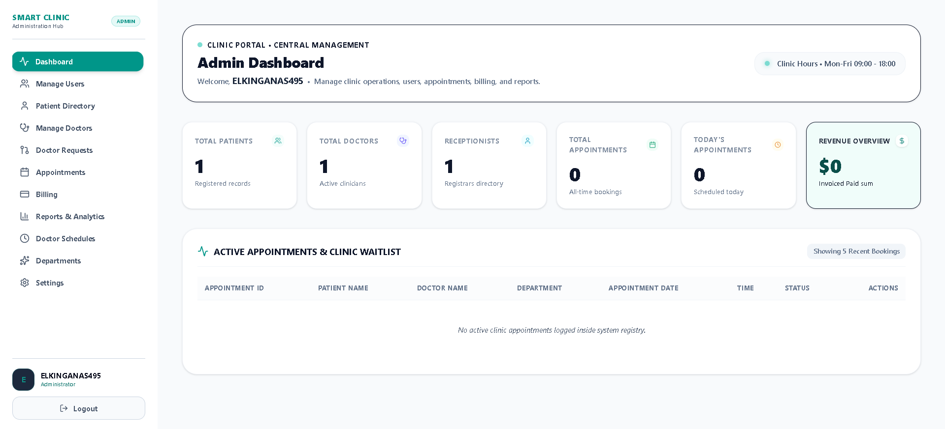

Admin Dashboard
Purpose:
The central control panel used by the Administrator to manage the entire clinic system.
Main Features:
- View clinic statistics (Patients, Doctors, Receptionists, Appointments, Revenue).
- Manage users and patient records.
- Manage doctors and approve doctor requests.
- Monitor appointments and billing.
- View reports and analytics.
- Manage departments, schedules, and system settings.
Database Interaction:
- Reads and updates data from Firebase collections:
  - Users
  - Patients
  - Doctors
  - Appointments
  - Billing
  - Departments
User Role:
- Administrator only.

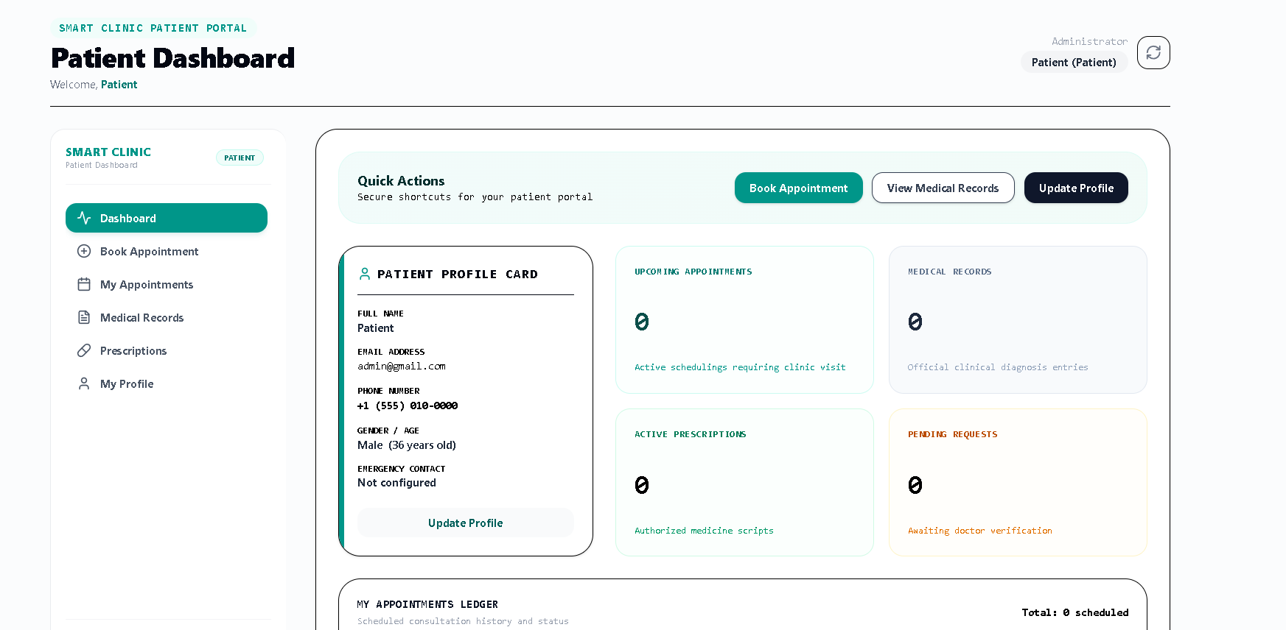

Patient Dashboard
Brief Description:
This page is the main portal for patients after logging in. It allows patients to manage appointments, view medical information, and update personal details.
Main Features:
- Quick Actions: Fast access to:
  - Book Appointment
  - View Medical Records
  - Update Profile
- Patient Profile Card: Displays personal information such as name, email, phone number, gender, and emergency contact.
- Upcoming Appointments: Shows scheduled future appointments.
- Medical Records: Displays the number of available medical records.
- Active Prescriptions: Lists current prescriptions issued by doctors.
- Pending Requests: Shows appointment or medical requests awaiting approval.
- Appointments Ledger: Provides a history of the patient's appointments and their status.
- Navigation Menu: Allows access to appointments, medical records, prescriptions, and profile management.
Purpose:
To give patients a centralized dashboard where they can manage their healthcare information and clinic interactions efficiently.

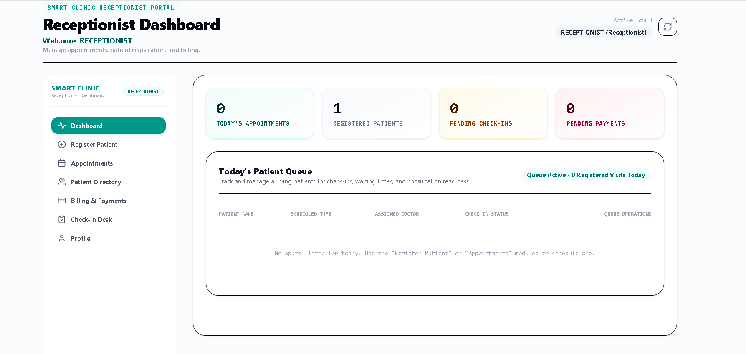

Receptionist Dashboard (Brief Explanation)
Purpose:
This page is used by the Receptionist to manage patients, appointments, check-ins, and billing activities.

Main Features:
- Dashboard Overview
  - Shows quick statistics:
    - Today's Appointments
    - Registered Patients
    - Pending Check-ins
    - Pending Payments
- Register Patient
  - Add new patients to the clinic system.
- Appointments
  - Schedule, update, or cancel patient appointments.
- Patient Directory
  - View and manage all registered patients.
- Billing & Payments
  - Process invoices and track payment status.
- Check-In Desk
  - Manage patient arrivals and appointment check-ins.
- Today's Patient Queue
  - Displays patients scheduled for today.
  - Shows appointment time, assigned doctor, and check-in status.
- Profile
  - View and update receptionist account information.

User Role:
The Receptionist acts as the communication bridge between patients and doctors, ensuring appointments, registrations, check-ins, and payments are handled smoothly.

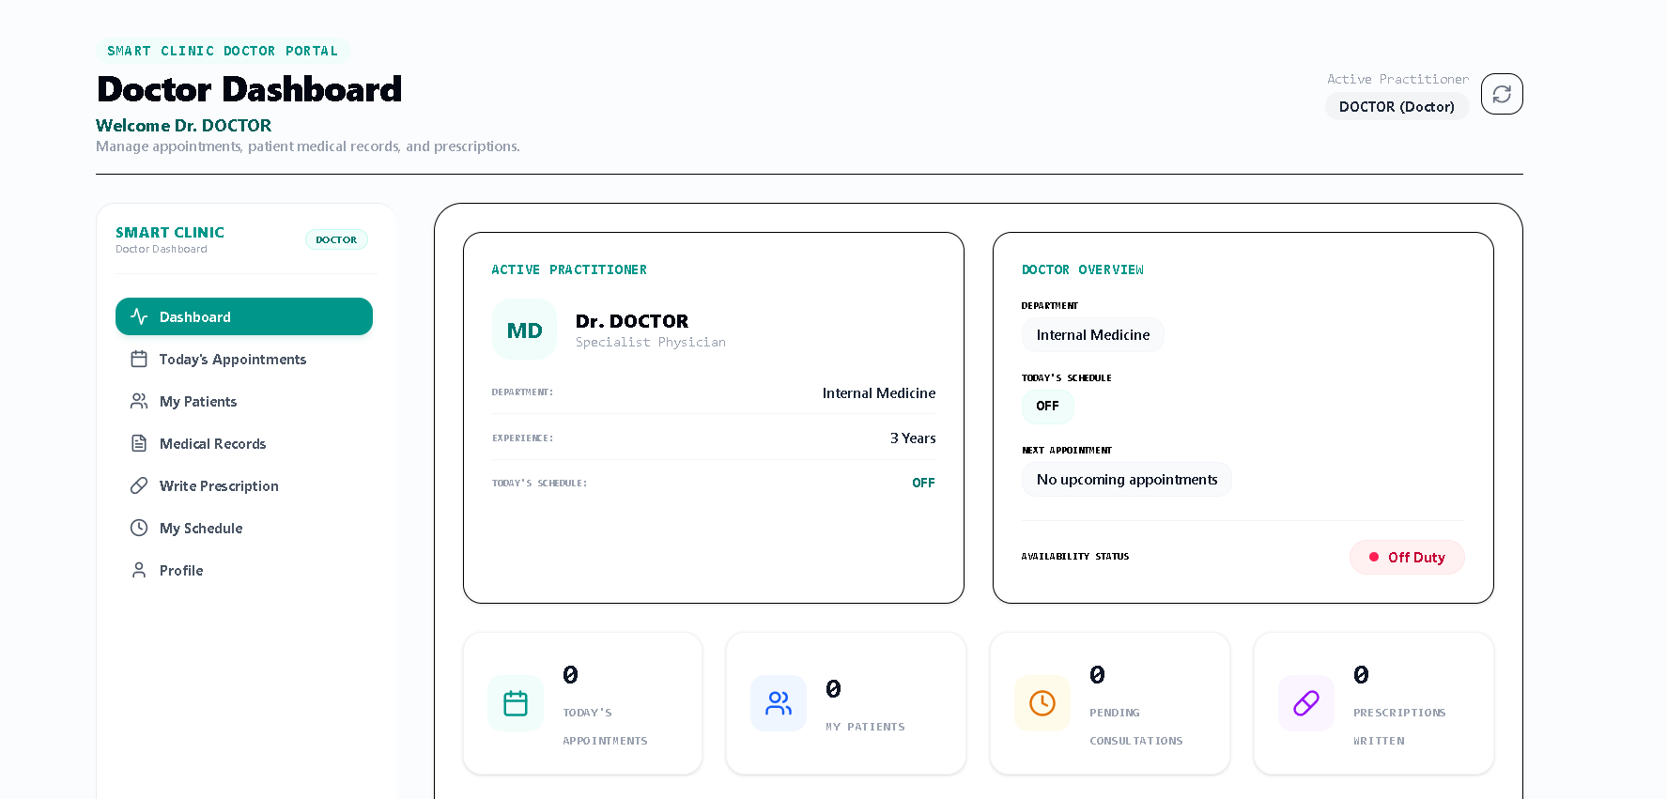

Doctor Dashboard (Brief Explanation)
Purpose:
This page is used by Doctors to manage appointments, patients, medical records, and prescriptions.

Main Features:
- Doctor Profile Overview
  - Displays doctor name, specialization, department, experience, and availability status.
- Today's Appointments
  - View scheduled consultations for the day.
- My Patients
  - Access assigned patient information and medical history.
- Medical Records
  - Review and update patient diagnoses and treatment records.
- Write Prescription
  - Create and manage patient prescriptions.
- My Schedule
  - View working hours and upcoming appointments.
- Statistics Cards
  - Total appointments today.
  - Number of assigned patients.
  - Pending consultations.
  - Prescriptions written.

User Role:
The Doctor is responsible for examining patients, updating medical records, managing consultations, and issuing prescriptions within the clinic system.

26. Testing
Testing is an essential phase in the software development lifecycle that ensures the Smart Clinic Management System functions correctly, meets user requirements, and operates reliably under different conditions. Various testing techniques were applied to verify system functionality, integration between modules, and user satisfaction.
The testing process focused on validating authentication, user management, appointment scheduling, medical records, prescriptions, billing, notifications, and audit logging functionalities.

28.1 Testing Strategy
The testing strategy adopted for the Smart Clinic Management System aimed to ensure that all system components function correctly both individually and collectively.
The testing process included:
- Functional Testing
- Integration Testing
- User Acceptance Testing (UAT)

Testing Objectives
The primary objectives of testing were:
- Verify that all functional requirements are implemented correctly.
- Ensure smooth interaction between system modules.
- Validate user authentication and authorization.
- Detect and fix defects before deployment.
- Confirm that the system meets user expectations.

Testing Process
- Test scenarios were identified based on system requirements.
- Test cases were prepared for each module.
- Tests were executed and results were documented.
- Identified issues were corrected.
- Regression testing was performed to verify fixes.
- Final acceptance testing was conducted before deployment.

28.2 Functional Testing
Functional testing was performed to verify that each feature of the system operates according to the specified requirements.

Modules Tested
- User Authentication
- User Management
- Patient Management
- Doctor Management
- Appointment Scheduling
- Medical Records
- Prescriptions
- Billing and Invoices
- Notifications
- Audit Logs

Functional Testing Results
Module | Test Status
Authentication | Passed
User Management | Passed
Patient Management | Passed
Doctor Management | Passed
Appointment Scheduling | Passed
Medical Records | Passed
Prescriptions | Passed
Billing & Invoices | Passed
Notifications | Passed
Audit Logs | Passed
The results indicate that all major system functions performed as expected and satisfied the functional requirements.

28.3 Integration Testing
Integration testing was conducted to verify communication and data flow between different system components.

Integration Areas Tested

Authentication and User Management
Verified that authenticated users are assigned correct roles and permissions after login.

Appointments and Patients
Verified that appointments are correctly linked to patient records.

Appointments and Doctors
Verified that appointments are correctly assigned to doctors.

Medical Records and Appointments
Verified that medical records are associated with the corresponding appointments.

Prescriptions and Medical Records
Verified that prescriptions are linked to the appropriate medical records.

Billing and Appointments
Verified that invoices are generated correctly based on appointment information.

Notifications and User Accounts
Verified that notifications are delivered to the appropriate users.

Integration Testing Results
All integrated modules exchanged data successfully without significant errors or inconsistencies.

28.4 User Acceptance Testing (UAT)
User Acceptance Testing was performed to ensure that the system satisfies the needs of its intended users and supports real-world clinic operations.
The system was evaluated from the perspective of the four user roles:
- Administrator
- Doctor
- Receptionist
- Patient

User Acceptance Criteria
The system was considered acceptable if users could:
- Successfully log in.
- Access authorized features.
- Perform their assigned tasks.
- Retrieve and update data correctly.
- Navigate the application without difficulties.

UAT Results
User Role | Result
Administrator | Accepted
Doctor | Accepted
Receptionist | Accepted
Patient | Accepted
The results confirmed that the system met the expectations of all intended user groups.

28.5 Test Cases
The following table presents a sample of the test cases executed during system validation.
Test Case ID | Test Scenario | Expected Result | Actual Result | Status
TC-01 | Login with valid credentials | User successfully logs in | Successful login | Pass
TC-02 | Login with invalid credentials | Access denied | Error message displayed | Pass
TC-03 | Create new patient | Patient record created | Record created successfully | Pass
TC-04 | Update patient information | Information updated | Information updated successfully | Pass
TC-05 | Add new doctor | Doctor record created | Record created successfully | Pass
TC-06 | Schedule appointment | Appointment created | Appointment scheduled successfully | Pass
TC-07 | Update appointment status | Status updated | Status updated successfully | Pass
TC-08 | Create medical record | Medical record stored | Record saved successfully | Pass
TC-09 | Generate prescription | Prescription created | Prescription generated successfully | Pass
TC-10 | Generate invoice | Invoice created | Invoice generated successfully | Pass
TC-11 | Send notification | Notification delivered | Notification received successfully | Pass
TC-12 | Create audit log entry | Activity recorded | Log created successfully | Pass

Testing Summary
A total of 12 representative test cases were executed across the major system modules.
Metric | Result
Total Test Cases | 12
Passed Test Cases | 12
Failed Test Cases | 0
Success Rate | 100%
The testing results demonstrate that the Smart Clinic Management System operates correctly and satisfies both functional and user requirements.

27. Challenges Faced
During the development of the Smart Clinic Management System, several technical and organizational challenges were encountered. These challenges provided valuable learning opportunities and contributed to improving the overall quality of the final system.

30.1 Migration from SQL Server to Firebase Firestore
One of the most significant challenges was migrating from the initial SQL Server database design to Firebase Firestore.
The project was originally designed using a relational database model, where entities were connected through primary and foreign key relationships. However, after evaluating the project requirements and deployment needs, the team decided to use Firebase Firestore as the final database solution.
This migration required:
- Redesigning the database structure.
- Converting relational tables into Firestore collections and documents.
- Reorganizing data relationships.
- Updating data access logic.
Although the migration required additional effort, it resulted in a more scalable and cloud-friendly solution.

30.2 Authentication and Authorization
Implementing secure authentication and authorization was another challenge.
The system supports multiple user roles, including:
- Administrator
- Doctor
- Receptionist
- Patient
Each role requires different permissions and access levels. Ensuring that users could only access authorized resources required careful integration between Firebase Authentication and the application's authorization logic.

30.3 Firestore Data Modeling
Unlike relational databases, Firestore uses a NoSQL document-based structure.
Designing efficient Firestore collections required:
- Understanding document-based architecture.
- Managing relationships without foreign keys.
- Optimizing data retrieval operations.
- Reducing redundant data storage.
The team had to carefully balance data normalization and performance requirements.

30.4 Role Management
Managing role-based access across multiple modules presented additional complexity.
The system needed to ensure that:
- Administrators have full access.
- Doctors can access patient medical information.
- Receptionists can manage appointments and billing.
- Patients can only access their own information.
Implementing these restrictions consistently throughout the application required extensive testing and validation.

30.5 Team Coordination and Development
As with many software projects, coordinating development tasks and maintaining consistency among team members required effective communication and planning.
Regular meetings, task distribution, and progress tracking helped the team overcome these challenges and successfully complete the project.

28. Lessons Learned
The Smart Clinic Management System provided valuable practical experience in software engineering, cloud technologies, and project management. Throughout the project, the team gained both technical and professional skills.

31.1 NoSQL Database Design
One of the most important lessons learned was understanding the differences between relational databases and NoSQL databases.
The team learned how to:
- Design Firestore collections and documents.
- Model relationships without foreign keys.
- Optimize data structures for scalability.
- Apply cloud database best practices.
This experience broadened the team's understanding of modern database technologies.

31.2 Firebase Ecosystem Integration
The project provided hands-on experience with Firebase services, including:
- Firebase Authentication.
- Firebase Firestore.
- Firestore Security Rules.
The team learned how these services can work together to create secure and scalable web applications with reduced infrastructure management.

31.3 Frontend Development Best Practices
Using React, TypeScript, Vite, and Tailwind CSS helped the team understand modern frontend development techniques, including:
- Component-based architecture.
- State management.
- Responsive design.
- Code organization and reusability.
These practices improved both development efficiency and application quality.

31.4 Team Collaboration
The project highlighted the importance of teamwork and communication throughout the software development lifecycle.
The team improved its ability to:
- Share responsibilities.
- Coordinate development activities.
- Resolve technical issues collaboratively.
- Meet project deadlines.

31.5 Agile Development Practices
The iterative nature of the project encouraged the use of agile development principles.
The team learned the importance of:
- Continuous improvement.
- Frequent testing.
- Requirement adaptation.
- Incremental development.
These practices helped ensure the successful completion of the project despite changes in technologies and implementation approaches.

29. Future Work
Although the Smart Clinic Management System successfully meets its current objectives, several enhancements can be implemented in future versions to improve functionality and user experience.

32.1 Mobile Application
A dedicated mobile application can be developed for Android and iOS devices.
Benefits include:
- Improved accessibility.
- Faster appointment management.
- Enhanced patient engagement.
- Mobile notifications.

32.2 Online Payment Integration
Future versions can integrate secure online payment gateways to allow patients to pay invoices electronically.
Potential benefits include:
- Faster payment processing.
- Improved billing management.
- Reduced administrative workload.

32.3 SMS and Email Notifications
The notification system can be extended to support SMS and email alerts.
Examples include:
- Appointment reminders.
- Prescription notifications.
- Billing updates.
- System announcements.

32.4 AI-Based Appointment Recommendations
Artificial Intelligence techniques can be integrated to assist in appointment scheduling.
Potential features include:
- Intelligent doctor recommendations.
- Appointment conflict detection.
- Schedule optimization.
- Predictive appointment management.

32.5 Multi-Clinic Support
The system can be expanded to support multiple clinics or healthcare branches within a single platform.
Benefits include:
- Centralized management.
- Shared patient records.
- Improved scalability.
- Enterprise-level deployment.

32.6 Advanced Analytics and Reporting
Future versions can include more advanced reporting and analytical dashboards to support data-driven decision-making.
Possible features include:
- Patient statistics.
- Revenue analysis.
- Doctor performance reports.
- Appointment trend analysis.

30. Conclusion

30.1 Project Summary
The Smart Clinic Management System was developed to provide an efficient and modern solution for managing healthcare operations within clinics and medical centers.
The system supports multiple user roles, including administrators, doctors, receptionists, and patients, and provides comprehensive functionality for managing appointments, medical records, prescriptions, billing, notifications, and user administration.
The project was implemented using modern web technologies, including React, TypeScript, Vite, Tailwind CSS, Firebase Firestore, Firebase Authentication, ASP.NET Core services, and Netlify deployment.

30.2 Achieved Objectives
The project successfully achieved its primary objectives, including:
- Providing secure user authentication and authorization.
- Managing patients and doctors efficiently.
- Supporting appointment scheduling and tracking.
- Maintaining electronic medical records.
- Managing prescriptions and billing information.
- Implementing notifications and audit logging.
- Deploying a scalable cloud-based solution using Firebase services.
The completed system satisfies both the functional and non-functional requirements identified during the analysis and design phases.

30.3 Final Remarks
The Smart Clinic Management System demonstrates the successful application of software engineering principles, modern web technologies, and cloud-based services in the healthcare domain.
The project provided valuable practical experience in system analysis, design, implementation, testing, deployment, and project management. Furthermore, it highlights the importance of adapting technology choices to project requirements, as demonstrated by the successful migration from a traditional relational database design to a cloud-based Firestore architecture.
Overall, the project achieved its goals and provides a solid foundation for future enhancements and real-world deployment in healthcare environments.

